

**숙제3 한국외대 네비게이션**

**과목명 컴퓨터그래픽스**

**담당교수 김상철교수님**

**제출일 20210622**

**전공 컴퓨터전자시스템**

**학번 201904458**

**이름 이준용**

* **소스 코드**

/* 제목 : 한국외대 컴퓨터 그래픽스 과제

프로그램 : 대학교 네비게이션

학 과 : 컴퓨터 전자시스템 전공

학 번 : 201904458

이 름 : 이준용 */

//#include<GL/glut.h>

#include<GL/glew.h>

#include <math.h>

#include<GL/freeglut.h>

#include<GL/gl.h>

#include <iostream>

using std::cout;

#define _USE_MATH_DEFINES // for C++

#define _CRT_SECURE_NO_WARNINGS

#define windowWidth 1000

#define windowHeight 1000

float x = 0.0f, y = 1.75f, z = 5.0f;

float lx = 0.0f, ly = 0.0f, lz = -1.0f;

int deltaMove = 0;

double rotate_x = 0.0;

double rotate_y = 0.0;

# define white 1.0 , 1.0 , 1.0

# define green 0.0 , 0.502, 0.0

# define red 1.0 , 0.0 , 0.0

# define gray 0.502, 0.502,0.502

# define hgray 0.117, 0.180,0.227

# define blue 0.0 , 0.0 , 1.0

# define pi 3.14159265

# define gold 1.0,215.0/255.0,0.0

# define hgreen 0.0,100.0/255.0,0.0

# define brown 210.0/255.0, 105.0/255.0, 30.0/255.0

# define men 244.0/255.0 ,164.0/255.0 , 96.0/255.0

# define menba 139.0/255.0 ,69.0/255.0,19.0/255.0

float fang[8][3];

float san[8][3];

float mat_ambient[] = { 0.2, 0.2, 0.2, 0.0 };

float mat_diffuse[] = { 0.6, 0.6, 0.6, 0.0 };

float mat_specular[] = {0.2, 0.2, 0.2, 0.0};

float mat_emissive[] = {0.0, 0.0, 0.0, 0.0};

float mat_shininess[] = {50.0};

GLuint Width = 1000, Height = 1000;

float x_Translation = 0.0, y_Translation = 0.0, z_move = 0.0;

float x_Rotation = 0.0, y_Rotation = 0.0;

float ww = 1000, hh = 1000;

static float angle = 0.0, ratio = 0.0;

void display(void);

void bmpReader(void);

static GLint imagewidth;

static GLint imageheight;

void init(void);

void keyboardDemo(unsigned char key, int x, int y);

void rotate(GLfloat ang);

void transla(GLint direct);

void trany(GLint direct);

struct Coordinate {

GLfloat x;

GLfloat y;

GLfloat z;

}cameraPos, sightLin, defaultVal;

void cons(double x, double y, double z, double x1, double y1, double z1) {

san[0][0] = x;

san[0][1] = y;

san[0][2] = z;

san[1][0] = x;

san[1][1] = y;

san[1][2] = z + z1;

san[4][0] = x;

san[4][1] = y + y1;

san[4][2] = z;

san[5][0] = x;

san[5][1] = y + y1;

san[5][2] = z + z1 / 2;

for (int i = 0; i < 3; i++) {

if (i == 0) {

san[3][i] = san[0][i] + x1;

san[2][i] = san[1][i] + x1;

san[6][i] = san[4][i] + x1;

san[7][i] = san[5][i] + x1;

}

else {

san[3][i] = san[0][i];

san[2][i] = san[1][i];

san[6][i] = san[4][i];

san[7][i] = san[5][i];

}

}

}

void constract(double x, double y, double z, double x1, double y1, double z1) {

fang[0][0] = x;

fang[0][1] = y;

fang[0][2] = z;

fang[1][0] = x;

fang[1][1] = y;

fang[1][2] = z + z1;

fang[2][0] = x + x1;

fang[2][1] = y;

fang[2][2] = z + z1;

fang[3][0] = x + x1;

fang[3][1] = y;

fang[3][2] = z;

for (int i = 0; i < 4; i++) {

for (int j = 0; j < 3; j++) {

if (j == 1)

fang[i + 4][j] = fang[i][j] + y1;

else

fang[i + 4][j] = fang[i][j];

}

}

}

void build2() {

glBegin(GL_POLYGON);

//glColor3f(red);

glNormal3f(0.0, -1.0, 0.0);

glVertex3f(san[0][0], san[0][1], san[0][2]);

glVertex3f(san[1][0], san[1][1], san[1][2]);

glVertex3f(san[2][0], san[2][1], san[2][2]);

glVertex3f(san[3][0], san[3][1], san[3][2]);

glEnd();

glBegin(GL_POLYGON);

//glColor3f(green);

glNormal3f(-1.0, 0.0, 0.0);

glVertex3f(san[1][0], san[1][1], san[1][2]);

glVertex3f(san[0][0], san[0][1], san[0][2]);

glVertex3f(san[4][0], san[4][1], san[4][2]);

glVertex3f(san[5][0], san[5][1], san[5][2]);

glEnd();

glBegin(GL_POLYGON);

//glColor3f(green);

glNormal3f(1.0, 0.0, 0.0);

glVertex3f(san[7][0], san[7][1], san[7][2]);

glVertex3f(san[6][0], san[6][1], san[6][2]);

glVertex3f(san[3][0], san[3][1], san[3][2]);

glVertex3f(san[2][0], san[2][1], san[2][2]);

glEnd();

glBegin(GL_POLYGON);

//glColor3f(green);

glNormal3f(0.0, 0.0, 1.0);

glVertex3f(san[5][0], san[5][1], san[5][2]);

glVertex3f(san[6][0], san[6][1], san[6][2]);

glVertex3f(san[2][0], san[2][1], san[2][2]);

glVertex3f(san[1][0], san[1][1], san[1][2]);

glEnd();

glBegin(GL_POLYGON);

//glColor3f(green);

glNormal3f(0.0, 0.0, -1.0);

glVertex3f(san[0][0], san[0][1], san[0][2]);

glVertex3f(san[3][0], san[3][1], san[3][2]);

glVertex3f(san[7][0], san[7][1], san[7][2]);

glVertex3f(san[4][0], san[4][1], san[4][2]);

glEnd();

glBegin(GL_POLYGON);

//glColor3f(red);

glNormal3f(0.0, 1.0, 0.0);

glVertex3f(san[4][0], san[4][1], san[4][2]);

glVertex3f(san[7][0], san[7][1], san[7][2]);

glVertex3f(san[6][0], san[6][1], san[6][2]);

glVertex3f(san[5][0], san[5][1], san[5][2]);

glEnd();

}

void build() {

glBegin(GL_POLYGON);

//glColor3f(red);

glNormal3f(0.0, -1.0, 0.0);

glVertex3f(fang[0][0], fang[0][1], fang[0][2]);

glVertex3f(fang[1][0], fang[1][1], fang[1][2]);

glVertex3f(fang[2][0], fang[2][1], fang[2][2]);

glVertex3f(fang[3][0], fang[3][1], fang[3][2]);

glEnd();

glBegin(GL_POLYGON);

//glColor3f(green);

glNormal3f(-1.0, 0.0, 0.0);

glVertex3f(fang[1][0], fang[1][1], fang[1][2]);

glVertex3f(fang[0][0], fang[0][1], fang[0][2]);

glVertex3f(fang[4][0], fang[4][1], fang[4][2]);

glVertex3f(fang[5][0], fang[5][1], fang[5][2]);

glEnd();

glBegin(GL_POLYGON);

//glColor3f(green);

glNormal3f(1.0, 0.0, 0.0);

glVertex3f(fang[7][0], fang[7][1], fang[7][2]);

glVertex3f(fang[6][0], fang[6][1], fang[6][2]);

glVertex3f(fang[2][0], fang[2][1], fang[2][2]);

glVertex3f(fang[3][0], fang[3][1], fang[3][2]);

glEnd();

glBegin(GL_POLYGON);

//glColor3f(green);

glNormal3f(0.0, 0.0, 1.0);

glVertex3f(fang[5][0], fang[5][1], fang[5][2]);

glVertex3f(fang[6][0], fang[6][1], fang[6][2]);

glVertex3f(fang[2][0], fang[2][1], fang[2][2]);

glVertex3f(fang[1][0], fang[1][1], fang[1][2]);

glEnd();

glBegin(GL_POLYGON);

//glColor3f(green);

glNormal3f(0.0, 0.0, -1.0);

glVertex3f(fang[0][0], fang[0][1], fang[0][2]);

glVertex3f(fang[3][0], fang[3][1], fang[3][2]);

glVertex3f(fang[7][0], fang[7][1], fang[7][2]);

glVertex3f(fang[4][0], fang[4][1], fang[4][2]);

glEnd();

glBegin(GL_POLYGON);

//glColor3f(red);

glNormal3f(0.0, 1.0, 0.0);

glVertex3f(fang[4][0], fang[4][1], fang[4][2]);

glVertex3f(fang[7][0], fang[7][1], fang[7][2]);

glVertex3f(fang[6][0], fang[6][1], fang[6][2]);

glVertex3f(fang[5][0], fang[5][1], fang[5][2]);

glEnd();

}

void display(void)

{

glClear(GL_COLOR_BUFFER_BIT | GL_DEPTH_BUFFER_BIT);

glMatrixMode(GL_MODELVIEW);

glLoadIdentity();

glRotatef(rotate_x, 0.1, 0.0, 0.0); // 위아래 회전

glRotatef(rotate_y, 0.0, 0.1, 0.0); // 왼 오른쪽 회전

gluLookAt(-500, 200, 500, 500, -10, 500, 0.0, 1.0, 0.0); // 초기 카메라 방향

gluLookAt(cameraPos.x, cameraPos.y, cameraPos.z,

cameraPos.x + sightLin.x, cameraPos.y + sightLin.y, cameraPos.z + sightLin.z,

defaultVal.x, defaultVal.y, defaultVal.z);

glRotatef(x_Rotation, 1.0, 0.0, 0.0);

glRotatef(y_Rotation, 0.0, 1.0, 0.0);

glTranslatef(-270, 0, -270);

glScalef(1.5, 1.5, 1.5);

glBegin(GL_POLYGON);

constract(0, 0, 500, 10000, 10, -49500); // 초록 잔디(왼쪽)

glColor3f(green);

build();

glBegin(GL_POLYGON);

constract(2700, 0, 100, 1000, 15, -1500); // 명수당

glColor4f(blue, 0.8);

build();

glBegin(GL_POLYGON); // 중앙도로

constract(0, 0, 500, 10000, 10, 100);

glColor3f(gray);

build();

glBegin(GL_POLYGON);

constract(0, 0, 600, 10000, 10, 50000); // 초록 잔디(오른쪽)

glColor3f(green);

build();

glBegin(GL_POLYGON);

constract(330, 20, 250, 140, 1, 250);

glColor3f(gray);

build();

for (int i = 0; i < 50; i++) { //5 도로 흰색 타일 부분

glBegin(GL_POLYGON);

constract(i * 100, 10, 500 + 45, 40, 1, 10);

glColor3f(white);

build();

}

glBegin(GL_POLYGON); // 자연대 하얀색 담장

constract(10, 10, 10, 20, 20, 480);

glColor3f(white);

build();

constract(30, 10, 10, 440, 20, 20);

glColor3f(white);

build();

constract(470, 10, 10, 20, 20, 480);

glColor3f(white);

build();

constract(30, 10, 470, 100, 20, 20);

glColor3f(white);

build();

constract(230, 10, 470, 100, 20, 20);

glColor3f(white);

build();

glBegin(GL_POLYGON);

constract(10, 10, 10, 20, 50, 20);

glColor3f(white);

build();

glBegin(GL_POLYGON);

constract(470, 10, 10, 20, 50, 20);

glColor3f(white);

build();

glBegin(GL_POLYGON);

constract(230, 10, 470, 20, 50, 20);

glColor3f(white);

build();

glBegin(GL_POLYGON);

constract(10, 10, 470, 20, 50, 20);

glColor3f(white);

build();

glBegin(GL_POLYGON); // 자연대 입구

constract(470, 10, 470, 20, 50, 20);

glColor3f(white);

build();

glBegin(GL_POLYGON);

constract(310, 10, 470, 20, 50, 20);

glColor3f(white);

build();

glBegin(GL_POLYGON);

constract(110, 10, 470, 20, 50, 20);

glColor3f(white);

build();

glColor3f(hgray);

for (int i = 35; i < 470; i += 25) // 검은색 담장

{

constract(15, 20, i, 6, 30, 6);

build();

}

for (int i = 35; i < 470; i += 25)

{

constract(475, 20, i, 6, 30, 6);

build();

}

for (int i = 35; i < 470; i += 25)

{

constract(i, 20, 15, 6, 30, 6);

build();

}

for (int i = 35; i < 110; i += 25)

{

constract(i, 20, 485, 6, 30, 6);

build();

}

for (int i = 250; i < 310; i += 25)

{

constract(i, 20, 485, 6, 30, 6);

build();

}

glColor3f(white);

constract(320, 10, 250, 10, 100, 220);

build();

constract(460, 10, 250, 10, 100, 220);

build();

glColor3f(hgray);

constract(320, 110, 250, 150, 10, 220);

build();

glColor3f(white);

constract(50, 10, 50, 12, 450, 200); //자연대 남쪽벽

build();

glColor3f(white);

constract(1000, 10, 50, 12, 450, 200); // 자연대 북쪽벽

build();

glColor3f(white);

constract(62, 10, 50, 950, 450, 12);

build();

glColor3f(white);

constract(62, 10, 235, 950, 450, 12);

build();

glColor3f(white);

constract(62, 60, 235, 950, 400, 12);

build();

glColor3f(white);

constract(162, 60, 235, 850, 400, 12);

build();

glColor3f(white);

constract(62, 110, 235, 950, 350, 12);

build();

glColor4f(blue, 0.35); //자연대 창문

for (int i = 0; i < 6; ++i) {

glPushMatrix();

glTranslatef(50 * i, 0, 0);

constract(62 + 50, 60, 235, 50, 50, 30);

build();

}

glPopMatrix();

glColor4f(blue, 0.35); //자연대 창문

for (int i = 0; i < 6; ++i) {

glPushMatrix();

glTranslatef(50 * i, 0, 0);

constract(62 + 50, 120, 235, 50, 50, 30);

build();

}

glPopMatrix();

glColor4f(blue, 0.35); //자연대 창문

for (int i = 0; i < 6; ++i) {

glPushMatrix();

glTranslatef(50 * i, 0, 0);

constract(62 + 50, 180, 235, 50, 50, 30);

build();

}

glPopMatrix();

glColor4f(blue, 0.35); //자연대 창문

for (int i = 0; i < 6; ++i) {

glPushMatrix();

glTranslatef(50 * i, 0, 0);

constract(62 + 50, 240, 235, 50, 50, 30);

build();

}

glPopMatrix();

glColor4f(blue, 0.35); //자연대 창문

for (int i = 0; i < 6; ++i) {

glPushMatrix();

glTranslatef(50 * i, 0, 0);

constract(62 + 50, 300, 235, 50, 50, 30);

build();

}

glPopMatrix();

glColor4f(blue, 0.35); // 입구 유리문

constract(330, 22, 450, 130, 90, 10);

build();

for (int i = 0; i < 6; i++) // 자연대 가는길

{

glColor3f(brown);

constract(235 - i * 15, 10, 250 + i * 40, 40, 2, 20);

build();

}

for (int i = 0; i < 12; i++) // 기숙사 가는길

{

glColor3f(brown);

constract(800 - i * 15, 10, 1100 - i * 40, 40, 2, 20);

build();

}

glColor3f(gold);

glTranslatef(250, 400, 0);

glutSolidSphere(35.0, 20, 20);

glTranslatef(-250, -400, 0);

glColor3f(brown); // 니므 몸통

constract(60, 10, 390, 15, 70, 15);

build();

glColor3f(hgreen);

glTranslatef(60, 70, 400); // 나무

glutSolidSphere(25.0, 20, 20);

glTranslatef(20, 0, 0);

glutSolidSphere(25.0, 20, 20);

glTranslatef(-10, 0, -10);

glutSolidSphere(25.0, 20, 20);

glTranslatef(0, 0, 20);

glutSolidSphere(25.0, 20, 20);

glTranslatef(0, 10, -10);

glutSolidSphere(25.0, 20, 20);

//기숙사 *******************************************

glMaterialfv(GL_FRONT, GL_AMBIENT, mat_ambient);

glMaterialfv(GL_FRONT, GL_DIFFUSE, mat_diffuse);

glMaterialfv(GL_FRONT, GL_SPECULAR, mat_specular);

glMaterialfv(GL_FRONT, GL_SHININESS, mat_shininess);

glMaterialfv(GL_FRONT, GL_EMISSION, mat_emissive);

glPushMatrix();

glTranslatef(-270, 0, -270);

glScalef(1.5, 1.5, 1.5);

glColor3f(brown);

constract(500, 200, 700, 560, 30, 400);

build();

glColor3f(white);

constract(500, -100, 700, 560, 300, 400);

build();

glColor4f(hgray, 0.35);

for (int i = 0; i < 9; ++i) {

glPushMatrix();

glTranslatef(0, 70 * i, 0);

constract(500, -100, 680, 700, 10, 2);

build();

glPopMatrix();

}

glColor4f(blue, 0.35);

for (int i = 0; i < 8; ++i) {

glPushMatrix();

glTranslatef(20 * i, 0, 0);

constract(500, -10, 680, 40, 40, 2);

build();

constract(500, -10, 680, 40, 40, 2);

build();

}

glPopMatrix();

glColor4f(blue, 0.35); // 1층 창문

for (int i = 0; i < 8; ++i) {

glPushMatrix();

glTranslatef(20 * i, 0, 0);

constract(500, 50, 680, 60, 40, 2);

build();

constract(500, 50, 680, 60, 40, 2);

build();

}

glPopMatrix();

glColor4f(blue, 0.35); // 2층 창문

for (int i = 0; i < 8; ++i) {

glPushMatrix();

glTranslatef(20 * i, 0, 0);

constract(500, 120, 680, 40, 40, 2);

build();

constract(500, 120, 680, 40, 40, 2);

build();

}

glPopMatrix();

glColor4f(blue, 0.35); // 3층 창문

for (int i = 0; i < 8; ++i) {

glPushMatrix();

glTranslatef(20 * i, 0, 0);

constract(500, 200, 680, 40, 40, 2);

build();

constract(500, 200, 680, 40, 40, 2);

build();

}

glPopMatrix();

glPushMatrix();

glTranslatef(500, 170, 680);

glScalef(0.4, 0.5, 2);

glColor3f(red); // hufs 로고

glLineWidth(5);

glutStrokeCharacter(GLUT_STROKE_ROMAN, 'H');

glutStrokeCharacter(GLUT_STROKE_ROMAN, ' ');

glutStrokeCharacter(GLUT_STROKE_ROMAN, 'U');

glutStrokeCharacter(GLUT_STROKE_ROMAN, ' ');

glutStrokeCharacter(GLUT_STROKE_ROMAN, 'F');

glutStrokeCharacter(GLUT_STROKE_ROMAN, ' ');

glutStrokeCharacter(GLUT_STROKE_ROMAN, 'S');

glLineWidth(1);

glPopMatrix();

glPopMatrix();

//*******************************************

//공학관**************************************

glMaterialfv(GL_FRONT, GL_AMBIENT, mat_ambient);

glMaterialfv(GL_FRONT, GL_DIFFUSE, mat_diffuse);

glMaterialfv(GL_FRONT, GL_SPECULAR, mat_specular);

glMaterialfv(GL_FRONT, GL_SHININESS, mat_shininess);

glMaterialfv(GL_FRONT, GL_EMISSION, mat_emissive);

glPushMatrix();

glTranslatef(800, 0, -1370);

glScalef(1.5, 1.5, 1.5);

glColor3f(white);

constract(500, 200, 1000, 700, 30, -1000);

build();

glColor4f(white, 0.99);

constract(500, -100, 1000, 700, 300, -1000);

build();

glColor4f(brown, 0.85);

for (int i = 0; i < 6; ++i) {

glPushMatrix();

glTranslatef(0, 60 * i, 0);

constract(500, -100, 1000, 700, -20, 5);

build();

glPopMatrix();

}

glColor4f(blue, 0.35); // 1층 창문

for (int i = 0; i < 8; ++i) {

glPushMatrix();

glTranslatef(20 * i, 0, 0);

constract(500, 50, 1000, 40, -20, 5);

build();

constract(500, 50, 1000, 40, -20, 5);

build();

}

glPopMatrix();

glColor4f(blue, 0.35); // 2층 창문

for (int i = 0; i < 8; ++i) {

glPushMatrix();

glTranslatef(20 * i, 0, 0);

constract(500, 120, 1000, 60, -20, 5);

build();

constract(500, 120, 1000, 60, -20, 5);

build();

}

glPopMatrix();

glColor4f(blue, 0.35); // 3층 창문

for (int i = 0; i < 8; ++i) {

glPushMatrix();

glTranslatef(20 * i, 0, 0);

constract(500, 180, 1000, 40, -20, 5);

build();

constract(500, 180, 1000, 40, -20, 5);

build();

}

glPopMatrix();

glPopMatrix();

//*******************************************

//도서관 *******************************************

glMaterialfv(GL_FRONT, GL_AMBIENT, mat_ambient);

glMaterialfv(GL_FRONT, GL_DIFFUSE, mat_diffuse);

glMaterialfv(GL_FRONT, GL_SPECULAR, mat_specular);

glMaterialfv(GL_FRONT, GL_SHININESS, mat_shininess);

glMaterialfv(GL_FRONT, GL_EMISSION, mat_emissive);

glPushMatrix();

glTranslatef(1000, 0, -70);

glScalef(1.5, 1.5, 1.5);

glColor3f(white);

constract(500, 200, 700, 660, 10, 400);//constract(-15, 20, 0, 30, 70, -30); 첫번째 인자 x축 정면

build();

glColor3f(brown);

constract(500, -100, 700, 660, 300, 400);

build();

glColor4f(white, 0.9);

for (int i = 0; i < 5; ++i) {

glPushMatrix();

glTranslatef(0, 70 * i, 0);

constract(500, -100, 640, 640, 10, 2);

build();

glPopMatrix();

}

glColor4f(blue, 0.35); // 1층 창문

for (int i = 0; i < 8; ++i) {

glPushMatrix();

glTranslatef(20 * i, 0, 0);

constract(500, -10, 680, 40, 40, 2);

build();

constract(500, -10, 680, 40, 40, 2);

build();

}

glPopMatrix();

glColor4f(blue, 0.35); // 2층 창문

for (int i = 0; i < 8; ++i) {

glPushMatrix();

glTranslatef(20 * i, 0, 0);

constract(500, 50, 680, 60, 40, 2);

build();

constract(500, 50, 680, 60, 40, 2);

build();

}

glPopMatrix();

glColor4f(blue, 0.35); // 3층 창문

for (int i = 0; i < 8; ++i) {

glPushMatrix();

glTranslatef(20 * i, 0, 0);

constract(500, 120, 680, 40, 40, 2);

build();

constract(500, 120, 680, 40, 40, 2);

build();

}

glPopMatrix();

glPushMatrix();

glTranslatef(500, 170, 680);

glScalef(0.4, 0.5, 2);

glColor3f(red); // 도서관 로고

glLineWidth(5);

glutStrokeCharacter(GLUT_STROKE_ROMAN, 'L');

glutStrokeCharacter(GLUT_STROKE_ROMAN, 'I');

glutStrokeCharacter(GLUT_STROKE_ROMAN, 'B');

glutStrokeCharacter(GLUT_STROKE_ROMAN, 'R');

glutStrokeCharacter(GLUT_STROKE_ROMAN, 'A');

glutStrokeCharacter(GLUT_STROKE_ROMAN, 'R');

glutStrokeCharacter(GLUT_STROKE_ROMAN, 'Y');

glLineWidth(1);

glPopMatrix();

glPopMatrix();

GLUquadricObj* pObj; // Quadric Object

pObj = gluNewQuadric();

glPushMatrix();

glColor3f(white); // 도서관 중앙홀(원기둥으로 표현)

glTranslatef(2000, 0, 900);

glRotatef(-90.0f, 1.0f, 0.0f, 0.0f);

gluCylinder(pObj, 100,100, 400, 260, 130);

glPopMatrix();

glPushMatrix();

glColor4f(brown,0.8); // 도서관 중앙홀(원기둥으로 표현

glTranslatef(2000, 0, 900);

glRotatef(-90.0f, 1.0f, 0.0f, 0.0f);

gluCylinder(pObj, 110, 110, 150, 260, 130);

glPopMatrix();

//*******************************************

glFlush();

glutSwapBuffers();

}

void init(void)

{

GLfloat sun_direction[] = { 100.0, 100.0, 100.0, 0.0 }; // 태양 조명

GLfloat sun_intensity[] = { 1.0, 1.0, 1.0, 1.0 }; // 태양 밝기

GLfloat ambient_intensity[] = { 0.5, 0.5, 0.5, 1.0 }; // 태양 어두운 부분

glEnable(GL_LIGHTING); // Set up ambient light.

glLightModelfv(GL_LIGHT_MODEL_AMBIENT, ambient_intensity);

glEnable(GL_LIGHT0); // Set up sunlight.

glLightfv(GL_LIGHT0, GL_POSITION, sun_direction);

glLightfv(GL_LIGHT0, GL_DIFFUSE, sun_intensity);

glEnable(GL_COLOR_MATERIAL); // Configure glColor().

glColorMaterial(GL_FRONT, GL_AMBIENT_AND_DIFFUSE);

cout << "The OpenGL version is: " << glGetString(GL_VERSION) << "\n";

cout << glGetString(GL_VENDOR) << "\n";

glLineWidth(10);

glClearColor(0.0, 0.0, 0.0, 0.0); // 전체 배경색 검은색으로 표현

glEnable(GL_BLEND);

glDisable(GL_DEPTH_TEST);

glBlendFunc(GL_SRC_ALPHA, GL_ONE);

glMatrixMode(GL_PROJECTION);

glOrtho(-ww,ww, -hh, hh, -ww, ww); // specify clipping volume

cameraPos.x = 0.0; cameraPos.y = 1.75; cameraPos.z = 5.0;

sightLin.x = 0.0; sightLin.y = 0.0; sightLin.z = -1.0;

defaultVal.x = 0.0; defaultVal.y = 1.0; defaultVal.z = 1.0;

}

void sightLine(int w, int h) { // reshape 부분

ratio = (w * 5)/ h;

glMatrixMode(GL_PROJECTION);

glLoadIdentity();

glViewport(0, 0, w, h);

gluPerspective(90, ratio, 1, 100000);

glMatrixMode(GL_MODELVIEW);

glLoadIdentity();

gluLookAt(0.1, 1, 500, 500, 10, 100,defaultVal.x, defaultVal.y, defaultVal.z);

}

void keyboardDemo(unsigned char key, int x, int y) { // 키보드조작(첨부파일내용에 오류가 있어서 제 마음대로 고쳤습니다.)

switch (key) {

case 'w': // 전진

transla(1);

break;

case 's': // 후진

transla(-1);

break;

case 'd': // 왼쪽(반시계방향)회전

rotate_y += 5;

break;

case 'a': // 오른쪽(시계방향)회전

rotate_y -= 5;

break;

case 'e': // 고개 위로

rotate_x += 5;

break;

case 'q': // 고개 아래로

rotate_x -= 5;

break;

case 27:

exit(0);

break;

default:

break;

}

glutPostRedisplay();

}

void transla(GLint direct) {

cameraPos.x = cameraPos.x + direct * (sightLin.x+1) * 10.3;

cameraPos.z = cameraPos.z + direct * sightLin.z * 0.3;

glLoadIdentity();

gluLookAt(cameraPos.x, cameraPos.y, cameraPos.z,

cameraPos.x + sightLin.x, cameraPos.y + sightLin.y, cameraPos.z + sightLin.z,

defaultVal.x, defaultVal.y, defaultVal.z);

}

int main(int argc, char** argv)

{

glutInit(&argc, argv);

glutInitDisplayMode(GLUT_DOUBLE | GLUT_RGB);

glutInitWindowSize(windowWidth, windowHeight);

glutInitWindowPosition(100, 100);

glutCreateWindow("한국외대 네비게이션_201904458_이준용");

init();

glBlendFunc(GL_SRC_ALPHA, GL_ONE_MINUS_SRC_ALPHA);

glEnable(GL_DEPTH_TEST);

glutReshapeFunc(sightLine);

glutDisplayFunc(display);

glutKeyboardFunc(keyboardDemo);

glutMainLoop();

return 0;

}

* **화면 dump**

**과제3으로 주신 ppt과제 설명에 조작키 관련 부분에서 오타가 있어서 다음과 같이 수정했습니다.**

**처음 실행했을 경우 기숙사 건물과 다른 건물의 창문이 정렬이 안되어 있습니다. 실행 화면을 클릭하거나 조작키를 누를 경우 정상적으로 보이게 됩니다.**

**★ w => 앞으로 전진**

**★ s => 뒤로 후진**

**★ a => 왼쪽(반시계방향)회전**

**★ d => 오른쪽(시계방향)회전**

**★ q => 고개 위로**

**★ e => 고개 아래로**

**★종료(esc)**

<프로그램 시작 화면>

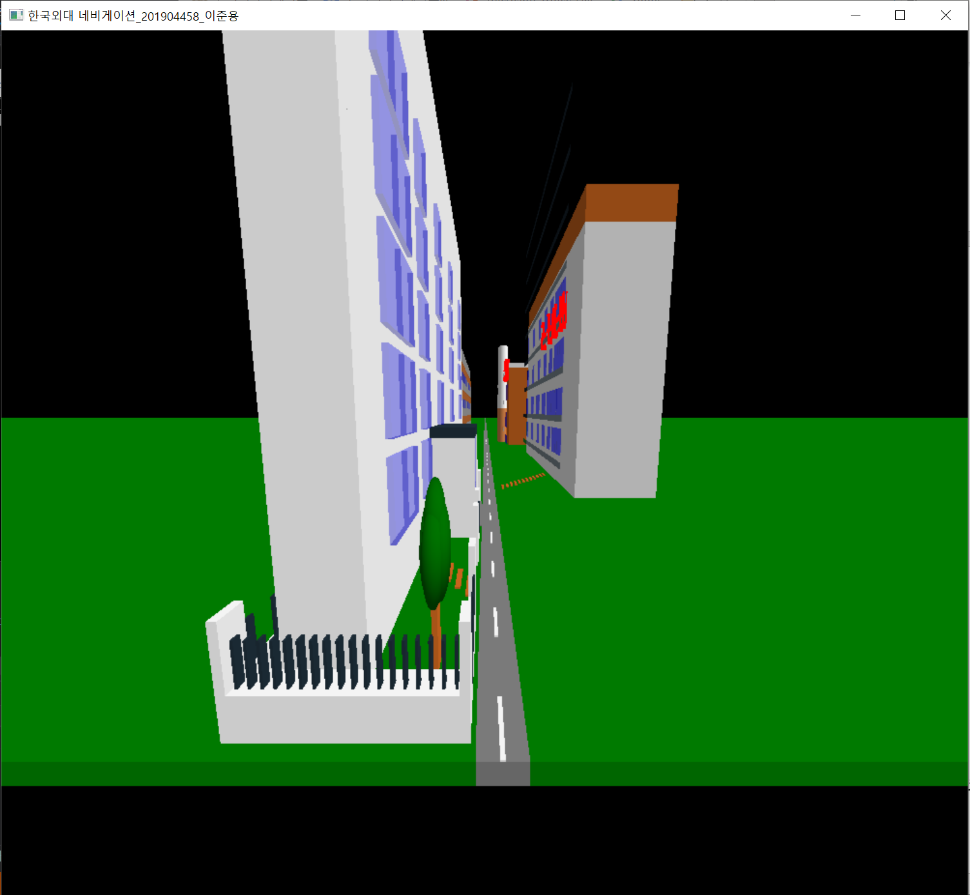

<프로그램 시작 후 키보드로 ‘w’키 10번 눌렀을 경우>

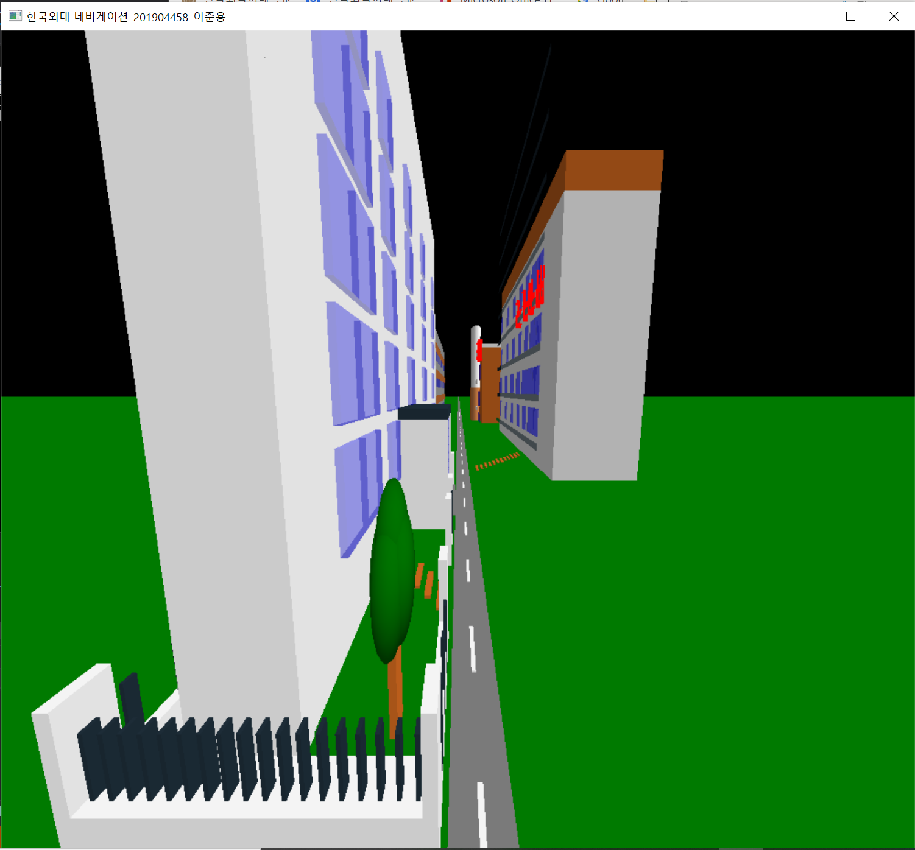

<프로그램 시작 후 키보드로 ‘s’키 10번 눌렀을 경우 >

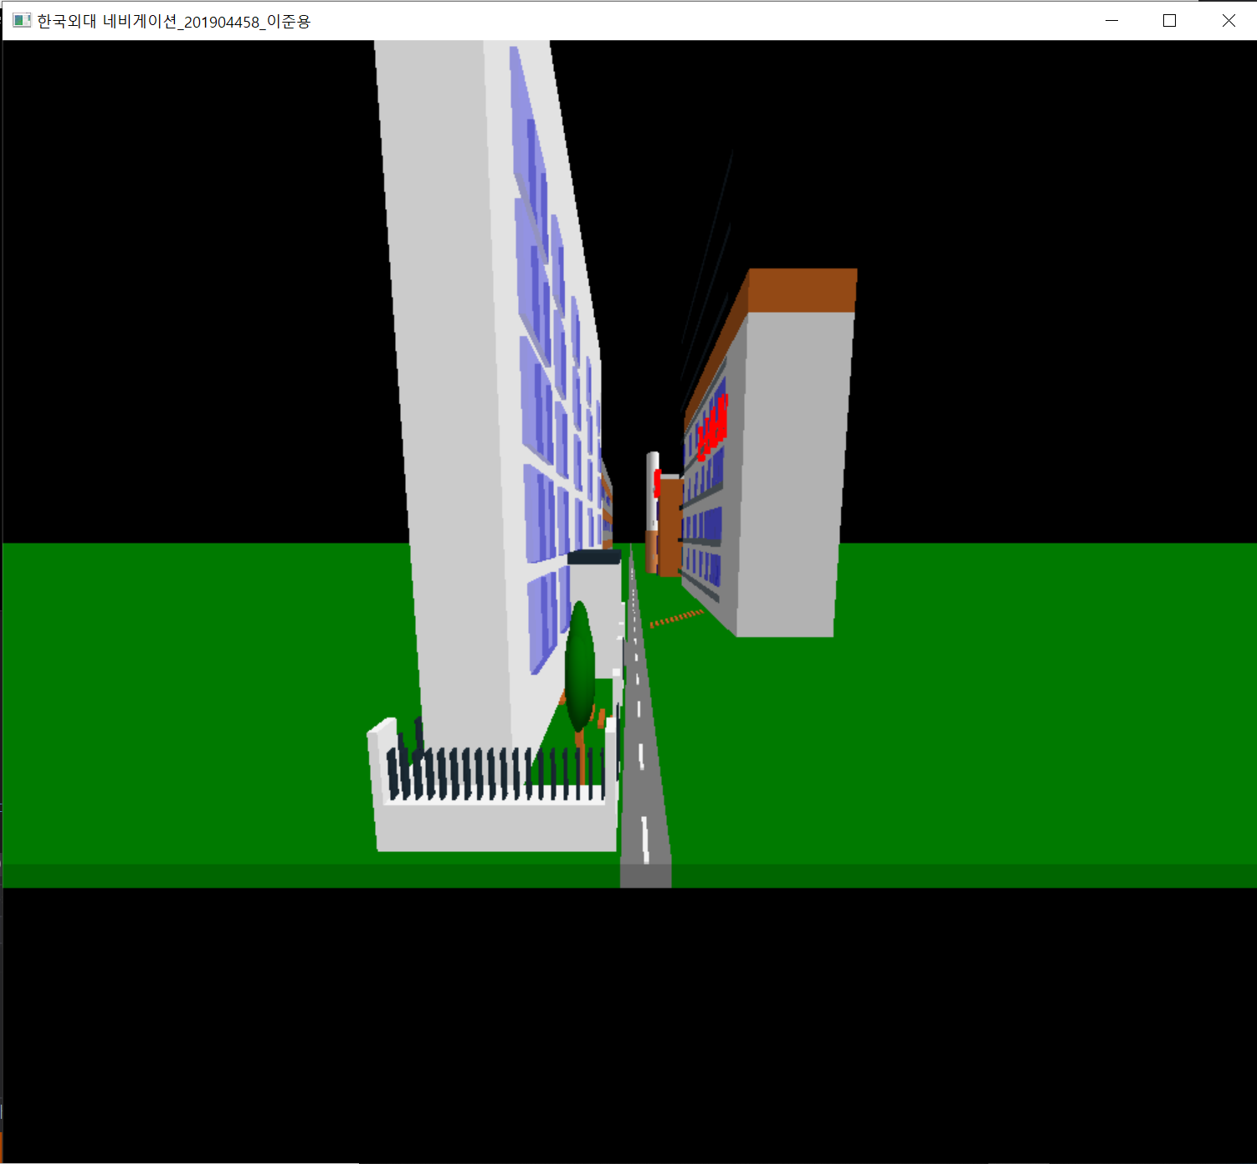

<프로그램 시작 후 키보드로 ‘a’키 3번 눌렀을 경우>

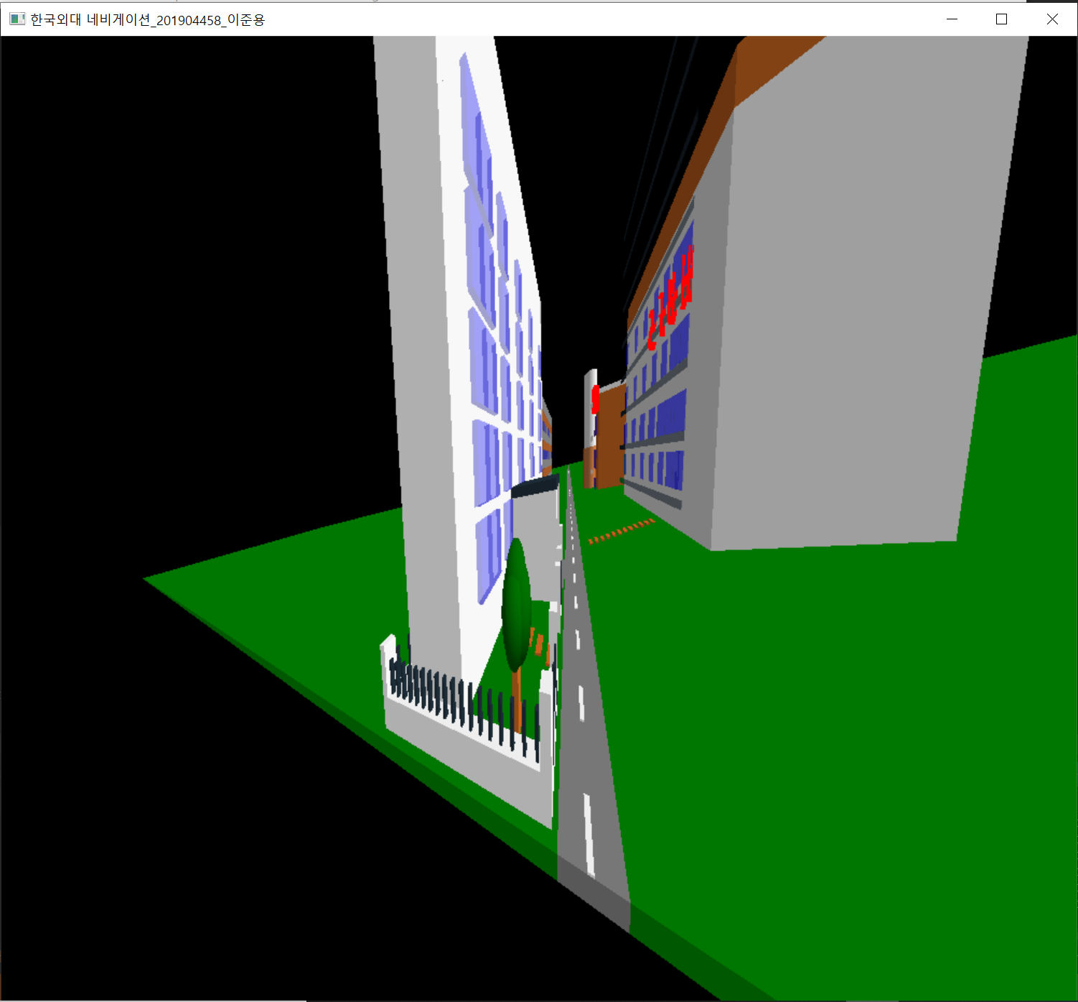

<프로그램 시작 후 키보드로 ‘d’키 3번 눌렀을 경우>

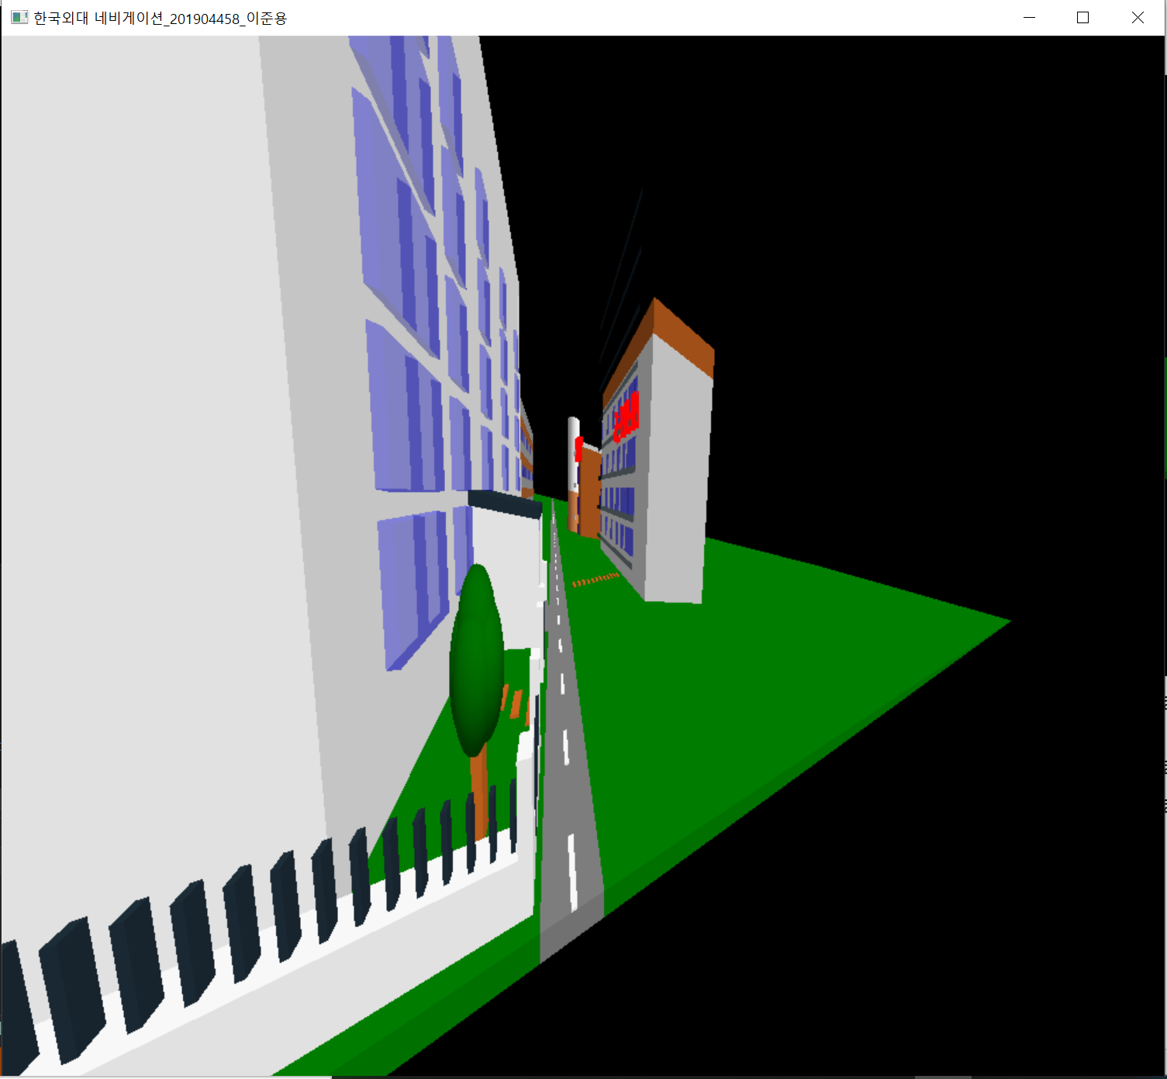

<프로그램 시작 후 키보드로 ‘q’키 눌렀을 경우>

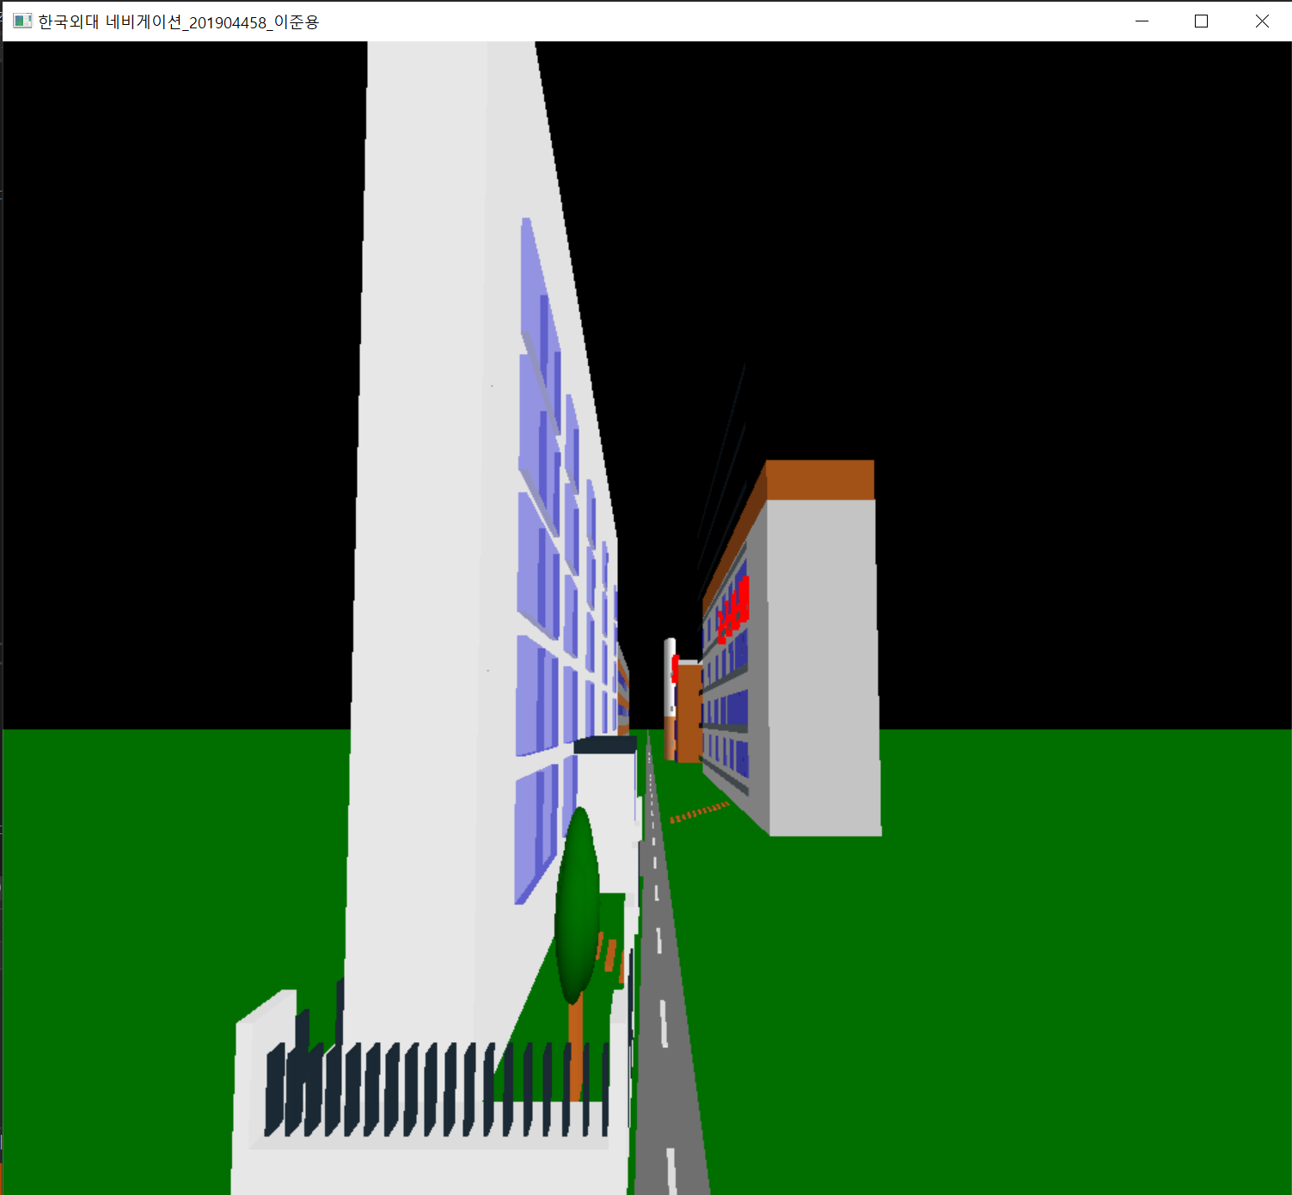

<프로그램 시작 후 키보드로 ‘e’키 3번 눌렀을 경우>

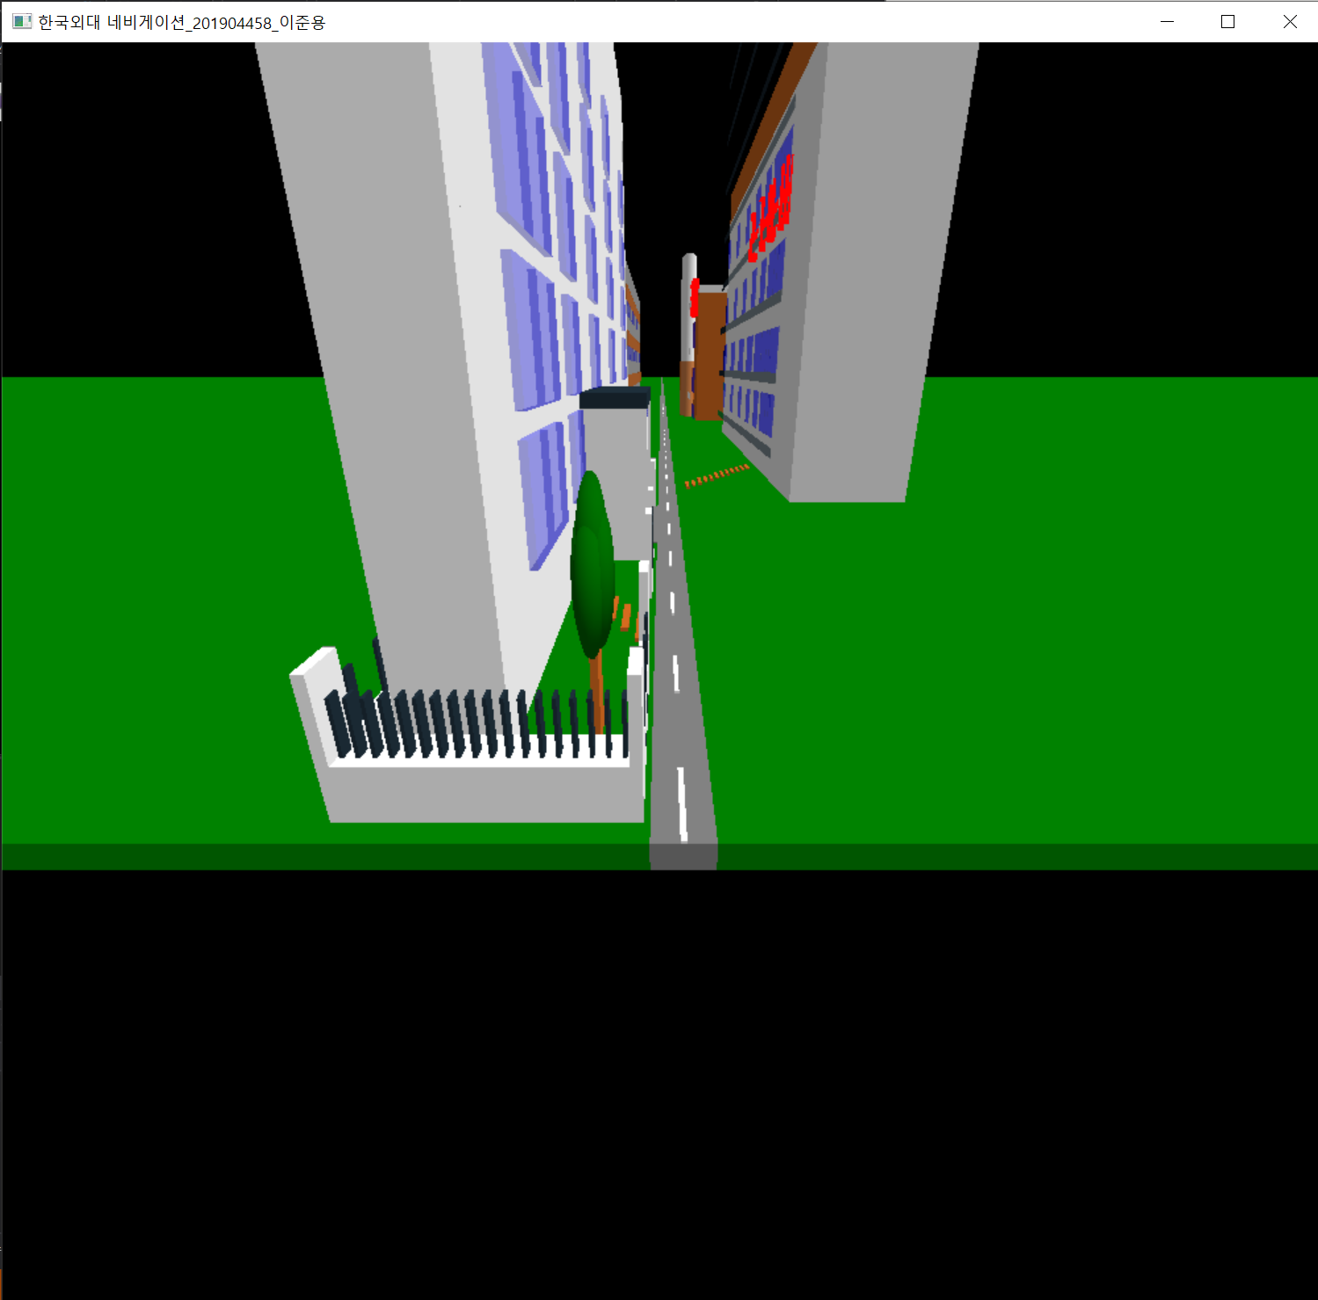

<프로그램 시작 후 키보드로 ‘w‘전진 후 자연대 건물(왼쪽)>

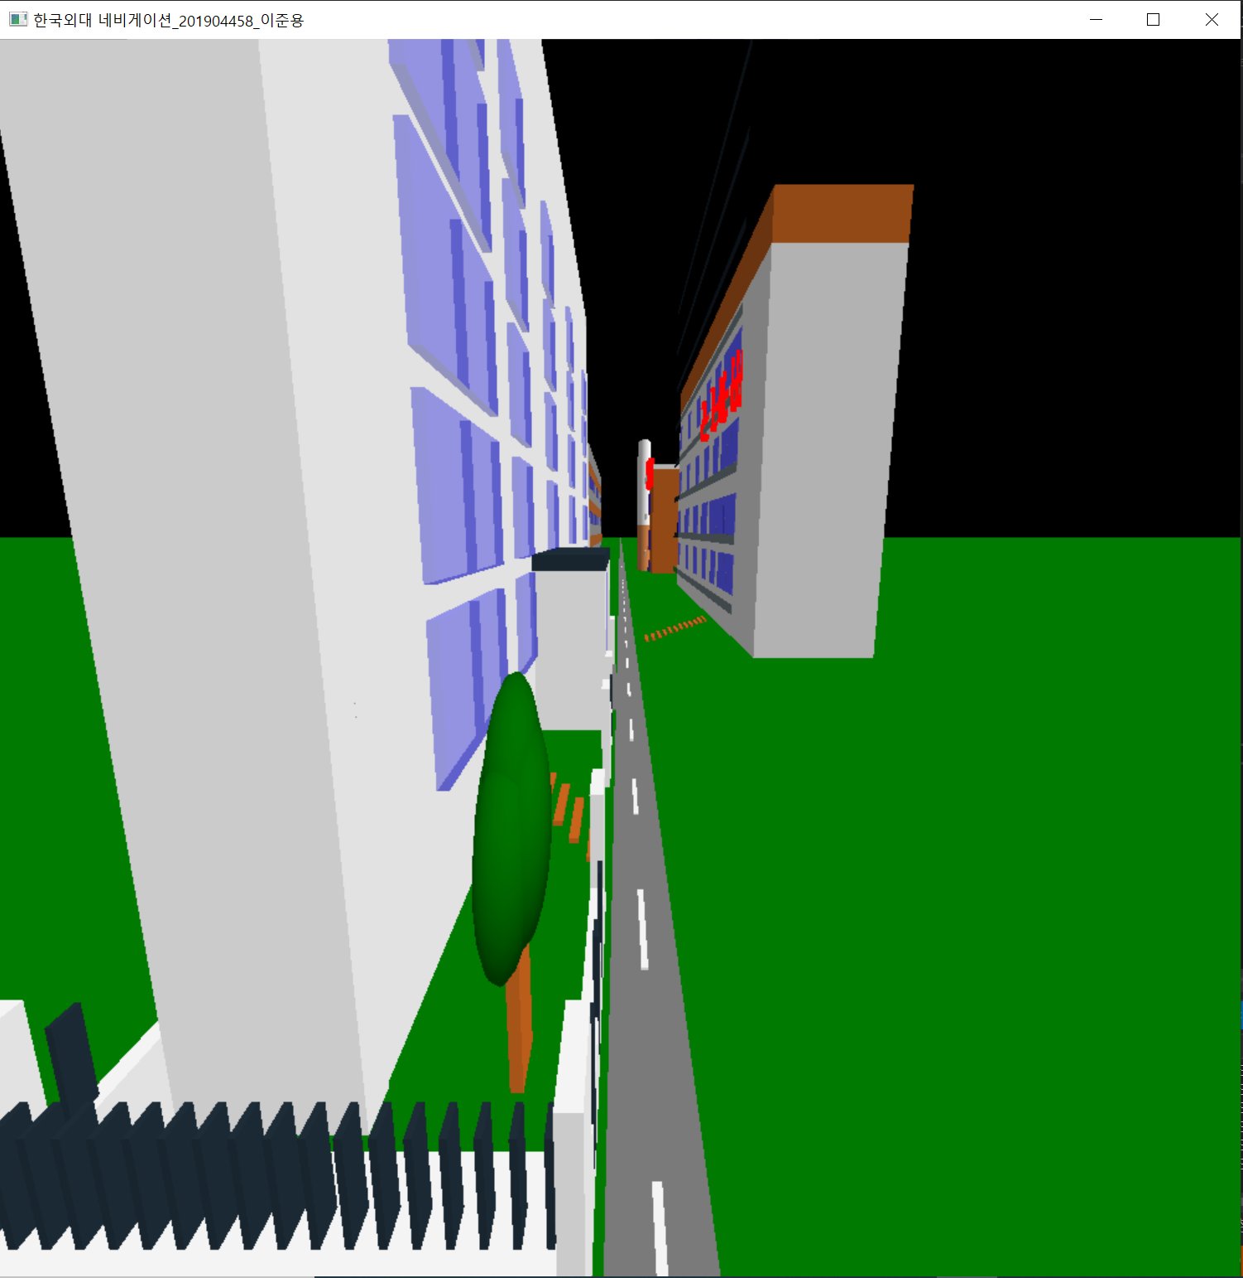

<프로그램 시작 후 키보드로 ‘w‘전진 후 기숙사 건물(오른쪽)>

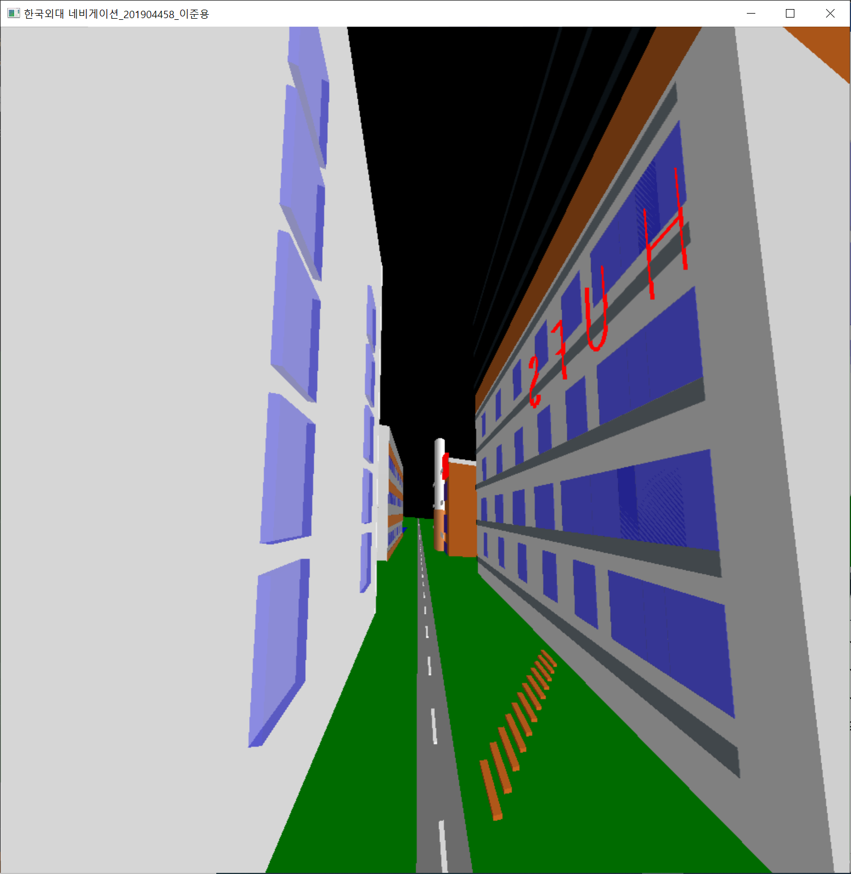

<프로그램 시작 후 키보드로 ‘w‘전진 후 공학관 건물(왼쪽)>

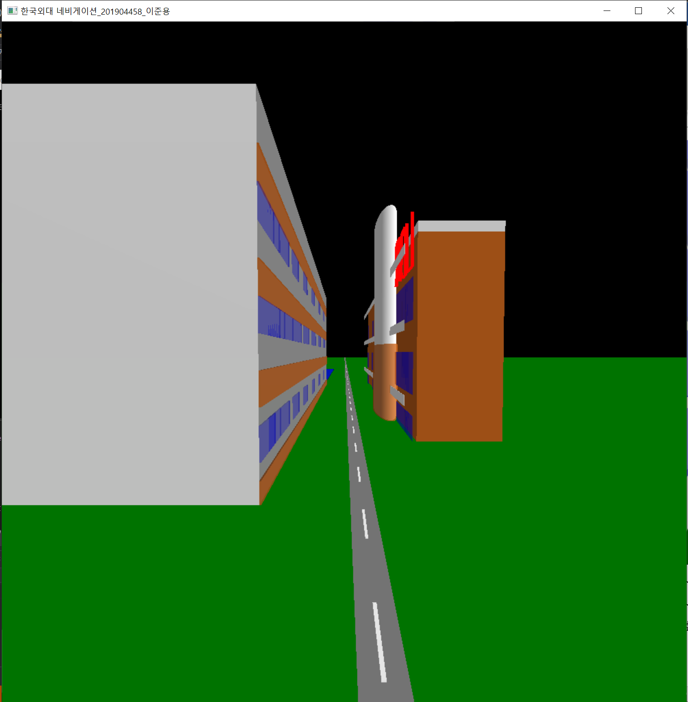

<프로그램 시작 후 키보드로 ‘w‘전진 후 도서관 건물(오른쪽)>

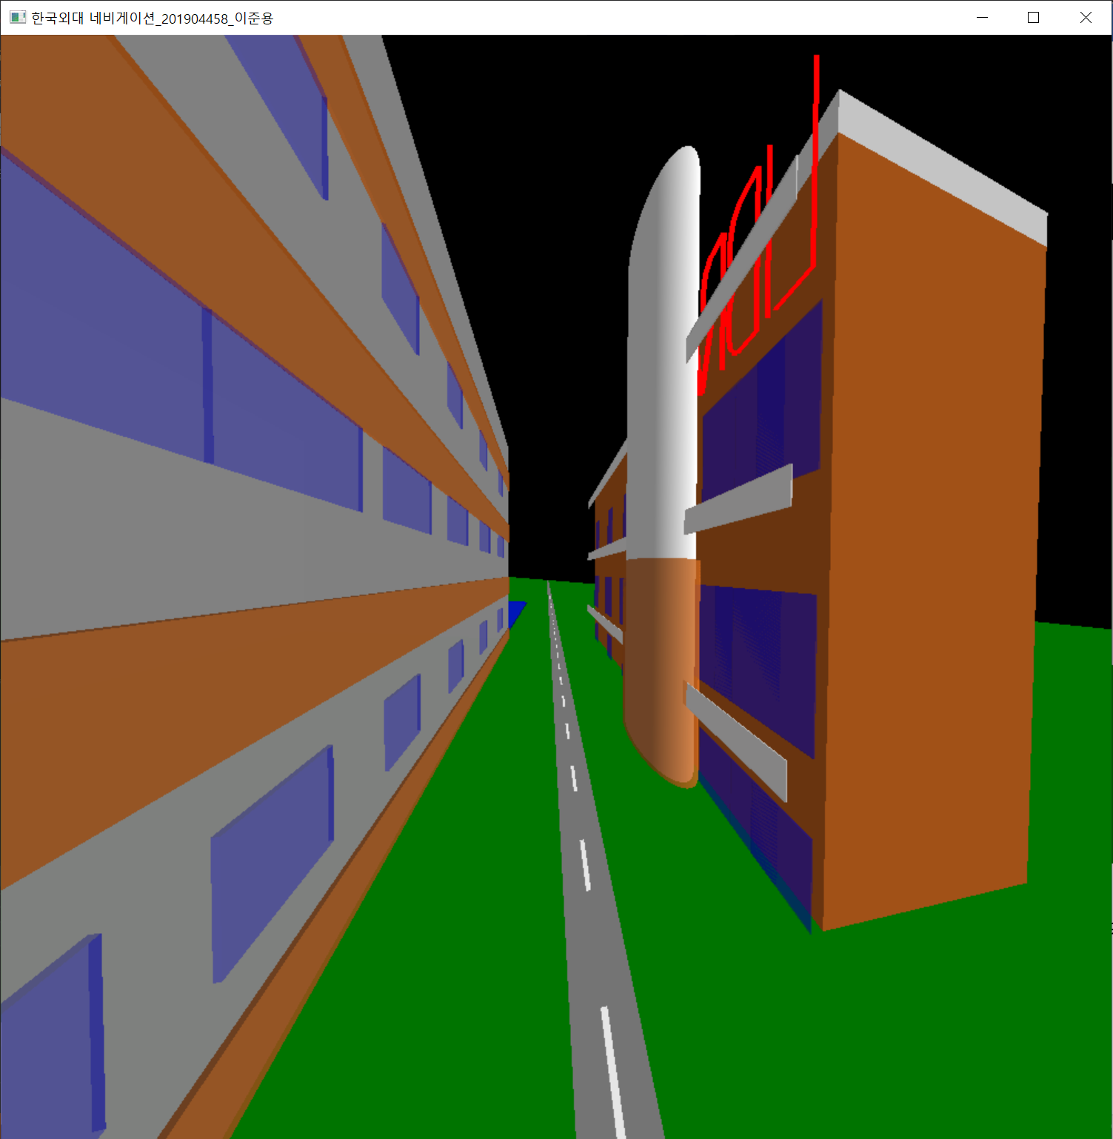

<프로그램 시작 후 키보드로 ‘w‘전진 후 명수당>

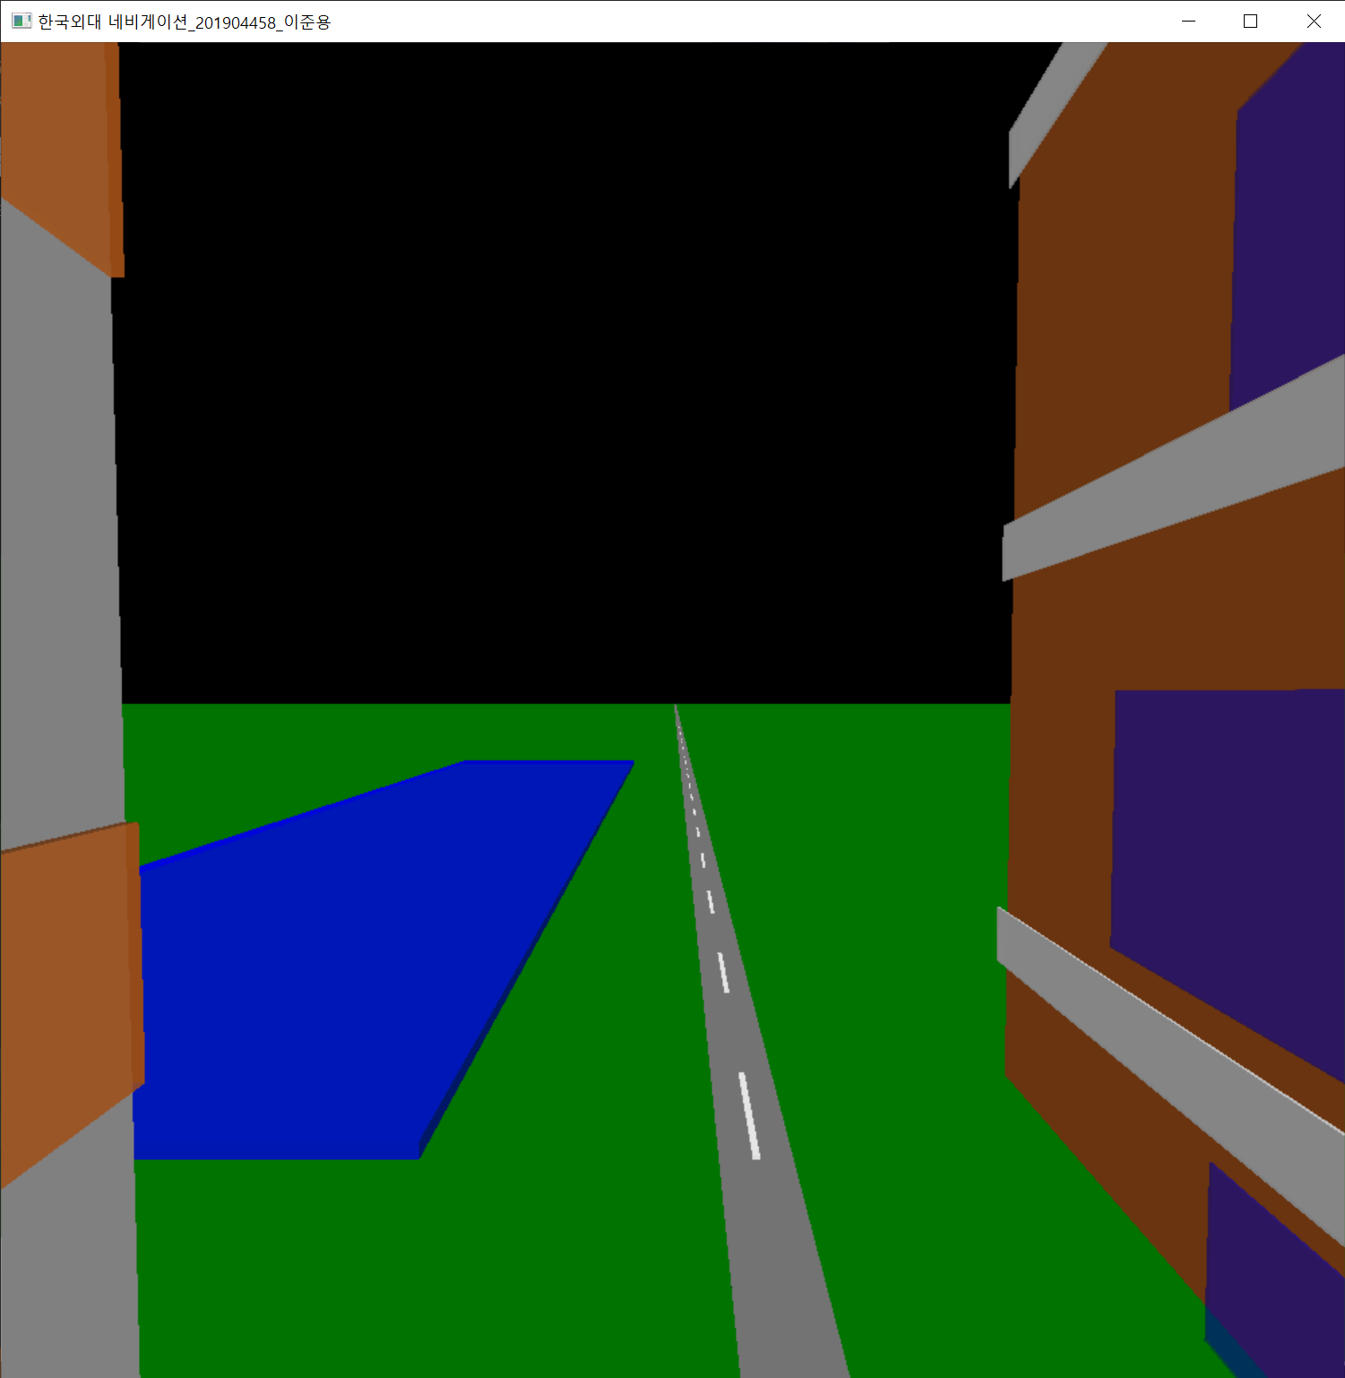

* **소감**

한국외대로 편입하고 컴퓨터 그래픽스 수업을 수강하면서OpenGL의 개념과 명령어들을 활용하는 법과 종류들과 함수들의 인자들 등 많은 것들을 습득하고 활용할 수 있게 되었습니다. 특히 glVertex3f 사용법, gluLokkAt함수, glColor3f, glColor4f, glBegin(GL_POLYGON), glPushMatrix, glPopMatrix함수들을 이번 과제를 하면서 자유롭게 다룰 수 있게 되었습니다.

한국외대 네비게이션 과제를 하면서 편입이후로 비대면 수업 때문에 대학교를 한번도 가보지 못했습니다. 그렇기에 대학교 건물을 사진만 보고 코딩해야 된다는 점에서 어려움이 있었습니다. 그렇기 때문에 더더욱 사진과 비슷하게 만들려고 노력했습니다. 2학기에 대면 수업이 된다면 제가 코딩했던 건물들의 외관과 강의실들을 실제로 보고 싶습니다.